Day 1 — Introduction to Agentic AI
Today I started learning Agentic AI and understood the difference between a normal AI model and an AI agent.

What is an AI Agent?
An AI agent is a system that can:
Observe → Think → Decide → Act
Unlike a chatbot, it does not just answer questions. It tries to complete a goal.
Example:
Normal AI:
User: Write a study plan
AI: Generates text

AI Agent:
User: Help me prepare for exams
Agent:
- Research syllabus
- Create plan
- Adjust schedule
- Track progress

LLM vs Agent
LLM:
- Generates responses
- Works only on prompts
- No actions

Agent:
- Uses LLM as brain
- Has memory
- Uses tools
- Performs tasks
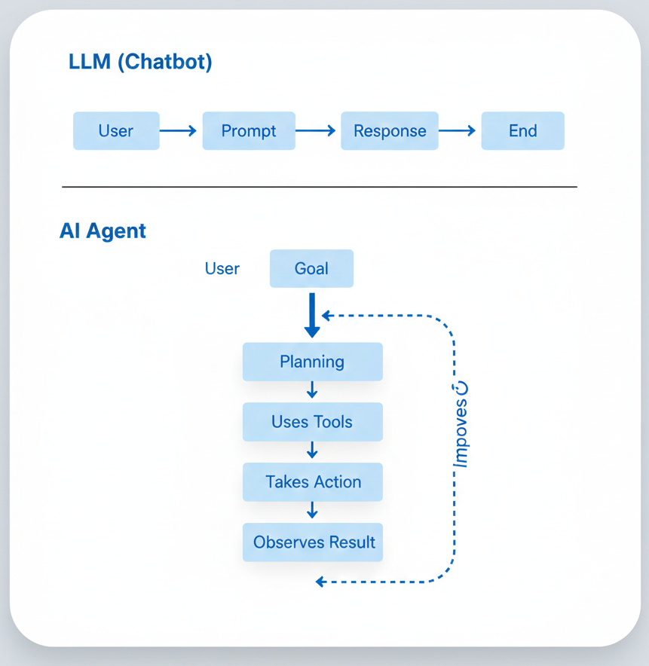
In simple words:
LLM = talks
Agent = works

Key Idea Learned
AI is evolving from question-answering systems to goal-completing systems.
Instead of asking multiple prompts,
we can give a single goal and the agent figures out how to achieve it.
This is why Agentic AI is powerful.

